* Dr Naela Aamir
** Dr Aqsa Malik

The Pioneers of Romanticism and Realism in the Landscape Paintings of Punjab

Abstract
The region of Punjab in Pakistan is the most fertile land of the country. The diversity of climate and the lush green fields with five rivers irrigating the land contribute to a visual spectacle of raw beauty. It is no surprise that the landscape painters found the land fascinating and in different ways tried to capture the beauty and subtlety of the land both as a visual delight and as a symbol of cultural identity. Broadly speaking, landscape painting in Punjab can be seen divided in two main artistic approaches, i.e. Romanticism and Realism. Both these approaches principally developed in the West as art movements in the 19th century, and due to their universal appeal seeped into the sensibility of the artists of East. This study discusses the work of the pioneers of the two approaches in Pakistan, namely, Ustad Allah Bakhsh and Khalid Iqbal. The study shows the unique contribution of both artists to the genre of landscape painting in Pakistan. The study argues that although both artist’s approach landscape from positions poles apart, nevertheless, they were intimately connected to the cultural identity of the region.
Keywords: Landscape Printing, Punjab, Romanticism, Realism, Cultural identity, abstractionism
Introduction
The sheer natural beauty of the landscapes has always inspired man. Whether it was from a position of inferiority, wherein, nature appeared to be mighty, majestic, and all powerful, or from a perspective of superiority destined to harness nature for human needs, there remained a constant comparison. However, regardless of the position man has taken vis-à-vis nature, the fascination has been never-ending. Landscape painting was born out of this fascination. As human civilization developed, the meaning and value of landscape acquired an aesthetic category of its own. It became a symbol of culture and identity in addition to being an expression of Mother Nature. The progression in the value of landscape also meant that there will be a corresponding development in the ways a landscape was perceived. The history of art is punctuated with this development in ways of seeing. These ways of seeing can be broadly classified into two categories. One was to observe what was out there and record it in maximum fidelity and the other was to add a subjective disposition to it. These two categories can be observed in all art that mankind has produced.
Landscape painting being a genre in itself can also be divided into two categories. One draws its inspiration from the mimetic approach to art in which the purpose is to create an illusion of reality on the canvas, the other is subtler; it involves changing the emotional impact of the visual by adding drama and theatricality. These approaches can be witness across the world, wherever art flourished. In the West, these became the seeds from which the movements of Romanticism and Realism germinated and became powerful features of artistic sensibility. The abundant visuals of landscape continued to inspire artists in many cultures and at various times. Both of these approaches met with greater opportunities to flourish in regions where there was fertile and peaceful land and where topology of land and climate created engaging visuals. It is not surprise that the likes of John Constable captured the English country side due to its simplicity, beauty and richness from a romantic perspective. By the same token, the region of Punjab in Pakistan became a focus of attention for landscape painters due to its sheer beauty, topology and climate creating dramatic light. Added to this was the cultural association of the people to its land manifest in folk literature and poetry. The following study explores the extent of Romantic and Realist approaches in the landscape paintings of two pioneers of the field; Ustad Allah Bakhsh and Khalid Iqbal.
Romanticism and Realism
Romanticism was principally an ideological movement that was initially expressed in literature and then engulfed other art forms in Europe. It was perspective that came into being as a reaction to the socio-political, socio-economic and socio-cultural environment that was a part and parcel of First Industrial Revolution. The mechanistic outlook of life, increased urbanization and growing dependency of man on machines was not welcome by sensitive factions of society. There emerged a greater preference for the simple past, where man was closer to nature. It emphasized the subjectivity of man by focusing on individuality and emotion. It also glorified nature, praised its beauty and celebrated man’s relationship with nature. In arts, particularly, the experience of intense emotion was considered to be an authentic source of aesthetic experience. This meant that the evocation of emotions like fear, horror, terror and awe would be the objective of romantic art. Casper David Friedrich went to the extent to state that “the artist’s feeling is his law”. Since, there was greater emphasis on creating an emotional appeal and intensity, therefore, imagination of the artist took the center stage.
On the one hand there was the approach of representing nature in its magnificence and might to produce what was called the experience of sublime in the viewer, on the other hand there was a love for simplicity of rural life, and the peaceful calming beauty of nature. For instance, in the paintings of Joseph Mallord William Turner, who was a master landscape painter of his time, the attention given to light, colour and atmosphere and the selection of theme all contributed to generate an experience of sublime. He portrayed nature as macabre and catastrophic, “finding special inspiration from fire and water, which, when stirred up, manifested incredible force.” This can be viewed in the following painting, wherein, human life is at the mercy of storm in a dramatic setting.
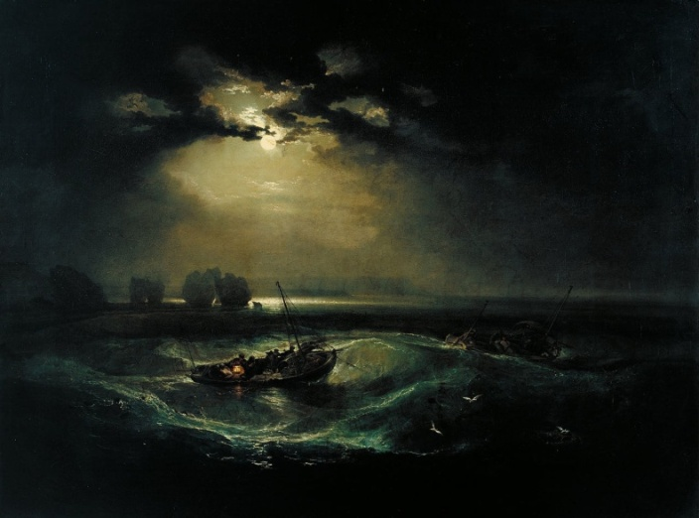
Figure 1. Joseph Mallord William Turner, Fishermen at Sea, Oil on canvas, 1796, Tate, London.
It is interesting to note that the whole idea of the experience of sublime revolves around connecting man to nature and fear is taken as a potent and primitive device. There is a dichotomy that defines the experience of sublime, “it offers us pleasure within fear because our incomprehension is taking place within a controlled environment”. However, not all romantic landscape painters used sublime as the objective of their art. John Constable, for example,preferred serenity, peace and calmness. He painted countryside to emphasize the beauty of nature in its simplicity as a painterly equivalent to the poetry of William Wordsworth. In The Heywain, Constable captures a splendid moment that blends the clouds, the land, water, light and wind into a vehicle of pure sentiment.
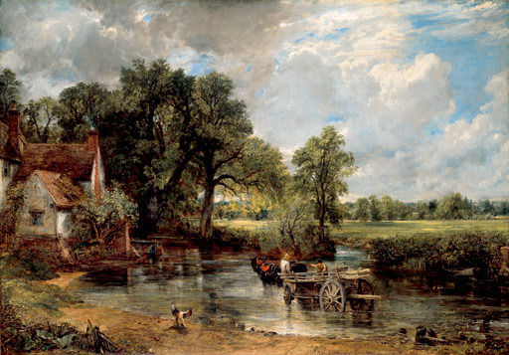
Figure 2. John Constable, Hay Wain, Oil on canvas, 130 cm × 185 cm, 1821, National Gallery, London.
The portrayal is intimate since it belongs to the artist’s love for the countryside. The individuality, emotion and subjective disposition are noticeable even though unlike turner the nature is not presented in its moments of power but in a naturalistic way. He expresses emotion but within the confines of order. Constable’s work was a reaction to the mechanistic world view which in the wake of industrial revolution had pushed back the ideals of pastoral life.
Realism began with the Barbizon School in France in 1820s. Theodore Rousseau and Jean-Francois Millet, and later on Gustav Courbet are considered the pioneers of Realism. They painted landscape simply from observation without any addition. It was a reaction against Romanticism on the account that romanticism provided an idealized picture of reality. Realism, “reflected the positivist belief that art should show unvarnished truth, and realists took up subjects that were generally regarded as not important enough for a serious work of art”.
Realism was all about painting nature for its own sake. The clear distinction that provided Realism its definition and contrasted it from Naturalism was Millet’s and Courbet’s work in the middle of 19th century. The produced landscape with and without human activity. Nature was the subject matter but they preferred to paint the real, the dark, and even the bitter reality as it appeared. There was another factor that contributed to such emphasis on the real; it was the rural life in France that made the fields a workplace rather than a place for leisure. Courbet, in particular showed through his paintings, the misery of the working class in The Stone Breakers. Bernard Goldman noted that “Courbet represents people as they are, and that he invents nothing and that no abstract, moralizing principles guide his hand”. In terms of subject matter, Realism was wider than mere capturing of nature. It was more importantly an attitude of depicting reality through observation through plein-air painting.
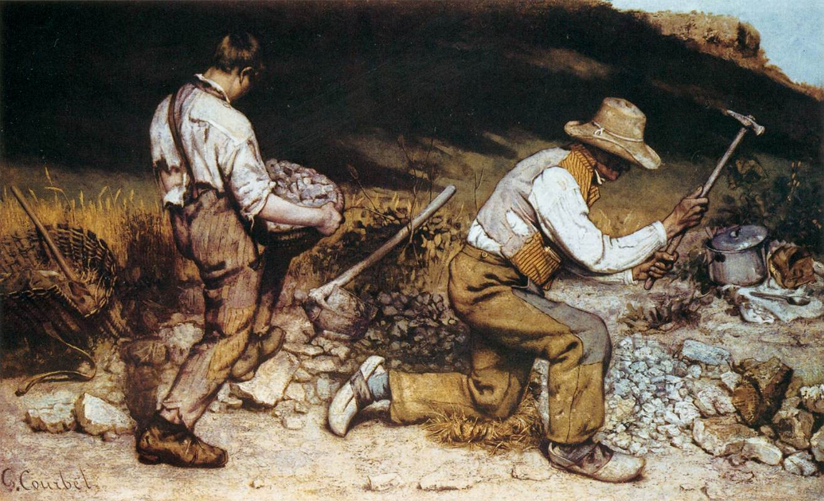
Figure 3. Gustav Courbet, The Stone Breakers, Oil on canvas, 1849.
A better understanding of Romanticism and Realism can only be developed in the context of the political scenarios of the times in which they emerged. In case of Subcontinent, the political scenario was different; it did not produce these movements. The artists adopted the aesthetic criteria and stylistic repertoire of these movements to some degree but since they were connected to their own political and cultural context, they had their unique contribution. From the Romantic, comes an attitude of portraying nature in terms of its might, expanse and sublimity or in terms of its beauty and simplicity. From the Realist, the artist borrowed the idea to depict what is observed without adding or subtracting. The former influenced Ustad Allah Bakhsh and the latter defined Khalid Iqbal, both, however, focused Punjab.
Landscape Painting in the Region of Punjab
It is interesting to note that the region of Punjab provided such subject matter that boot these artistic preferences found a place. Punjab due to its agrarian land and diverse climate has vast stretches of land, beautiful rural landscape and lush green gardens with rivers and tributaries providing the essential moisture. The interplay of light in summers and winters and other weathers reaching twelve according to local understanding attracted the landscape painters to capture the colours and shades in breath-taking moments. For instance, in the following poetry, Hafeez Jalandhari illustrates the spell-binding beauty of river Ravi.
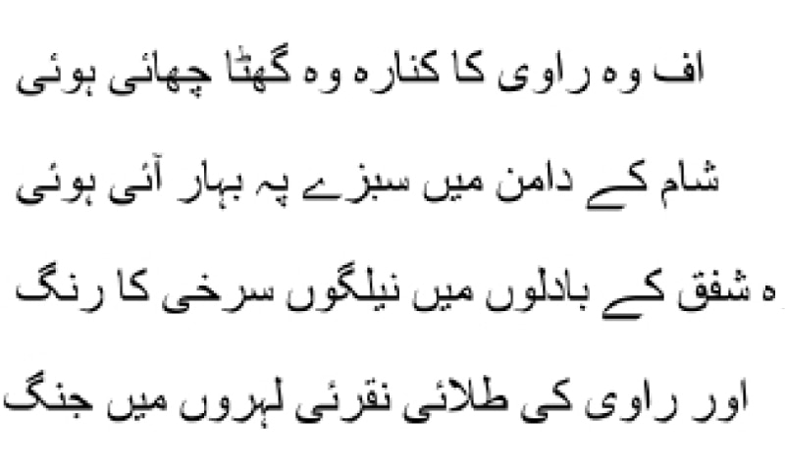
Translation: Ah! the banks of river Ravi with dark clouds covering them, the greenery in full bloom in the lap of evening, the violet red at the horizon of dusk, and the golden waves of Ravi in perpetual fight.
At the same time, there was an increasing urbanization particularly in Lahore that produced slums as well. The contrast between the natural and urban was perfect recipe for a realist portrayal. Mushtaq Soofi commented the same in following words, “Dynamics of uneven development find their concrete expression when village is juxtaposed against an urban space. Once a village develops into a town or city what remains out of its ambit continues to vegetate and thus treated as backwater”. The disorder, the chaos, the difference of class, the human habitat in the midst of natural surroundings, became the themes for a realist landscape artist.

The first landscape painter of Pakistan focusing on the region of Punjab was undoubtedly Ustad Allah Bakhsh. He was a product of non-academic tradition of the Subcontinent in which there existed a master-apprentice relationship within artist families. One such family was Habibullah family that influenced Ustad Allah Bakhsh in his formative years. He was the disciple of Muhammad Abdullah who was a member of the Habibullah family and ran an office at Royal Park, Lahore. The initial learning curve of Ustad Allah Bakhsh was impacted by painting advertisement boards for theatre companies.His association with theatre of Agha Hashar Kashmiri also contributed to his preference for the use of imagination. For a period of five years, he worked in Bombay at a photography studio. Ustad Allah Bakhsh, later on drew inspiration from the work of Archibald Herman Müller, who worked in India in the twentieth century. His forte was painting through memory and imagination. Ustad Meeran Bakhsh Naqqash, a teacher at National College of Arts also influenced Ustad Allah Bakhsh’s repertoire of style. These diverse influences contributed to Ustad Allah Bakhsh artistic sensibility in several ways. Infect, each influence integrated and a mature style came out of it. There was photographic accuracy, there was a love for folklore, and there was an ability of painting through imagination. These aspects multiplied with the recent past of company paintings, giving rise to an Indo-European style. In his youth, he witnessed a turbulent time in the history of Subcontinent due to the conflict between Muslim and Hindu identity. He, therefore, had a powerful sense of Muslim identity. All these aspects in one way or another contributed to Ustad Allah Bakhsh romantic inclination.
This training inspired Ustad Allah Bakhsh to paint folklore characters in rural backdrops. For instance, Heer Ranjha, two characters of Punjabi epic poetry found their place in Ustad Allah Bakhsh landscapes, which can be seen as romanticized expressions of the Punjabi past. The epic of Heer Ranjha by Waris Shah was a symbol of Punjabi culture on many grounds. The most important was the Sufi context which through a powerful symbolism immortalized these characters. Ranjha symbolized the journey of soul through the stages of Ishq, and Heer represented the revolt to stagnant traditions. Ustad Allah Bakhsh, in fact, brought to forefront the true cultural identity of Punjab imbued in the once thriving tradition of Sufism. The romantic spirit can be seen in reinventing the idealized past, the simple, rural but at the same time profound.
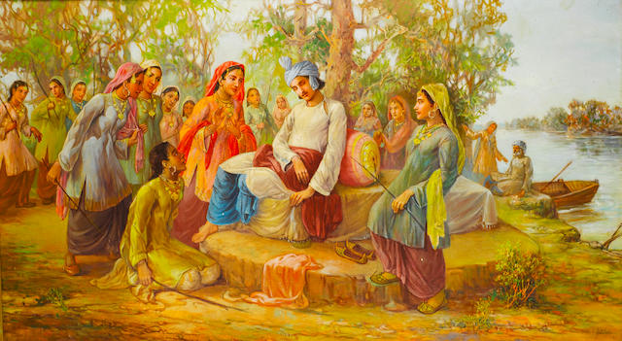
Figure 4. Ustad Allah Bakhsh, Ranjha at the Bank of Ravi, Oil on canvas, 1960s.
The expression of sublime, which has been a central characteristic of romantic landscape painting in the West can be observed in The Storm by Ustad Allah Bakhsh. The composition reminds of the work of Turner as the foreground occupies the one third of the vertical stretch. The colour palette is dramatized and accentuates a dream-like appearance. The interplay of light, cloud and the surface of water coupled with the expression of wind communicated through the inclined foliage create an atmosphere identifiable as the onset of a storm. The painting expresses the might of nature in the romantic fashion and compels the viewer to contemplate the relationship between man and nature. The painting undoubtedly represents the season of monsoon in the region of Punjab. It is a dramatized portrait of Punjab’s landscape with a theatricality and movement typical of romantic painters expressing the power of mother nature.
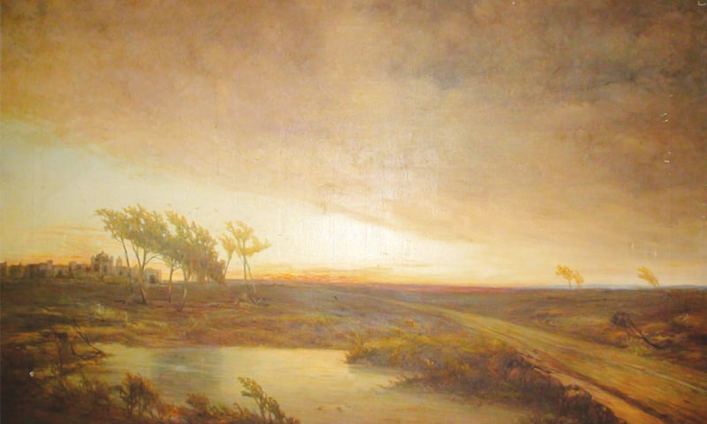
Figure 5. Ustad Allah Bakhsh, The Storm, Oil on canvas, 1967, Lahore Museum, Lahore.
Even the landscape paintings including human subjects were a product of imagination seeking a cultural expression of the region of Punjab. For instance, the illustrative outlook of the following painting is an idealized depiction of the agrarian land of Punjab and its farmers. The painting celebrates the cultural identity of Punjab. The anatomical detail of the bulls is meticulous representing perfect bodies. The atmosphere is bright and lucid, illuminating the land under the feet of farmers. One glance at the sky shows that it’s a bright and sunny summer day of Punjab. Akbar Naqvi states that Ustad Allah Bakhsh “created his own pictorial images from Punjab, its villages, folklore, and even the sky. These attempts to redefine his land were personal statements of good intention”.
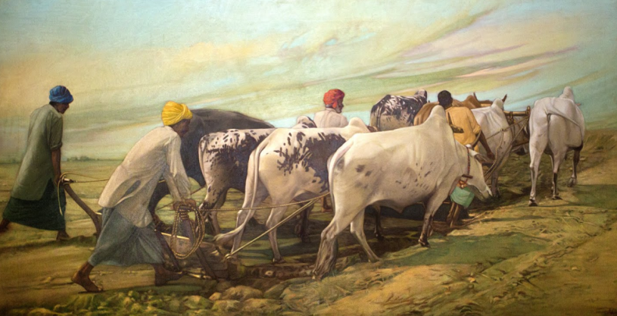
Figure 6. Ustad Allah Bakhsh, Farmers, Oil on canvas, 1950s.
The Pakistani painter, who consistently worked as Realist in landscape painting, was undoubtedly Khalid Iqbal. Khalid Iqbal was influenced by three sources. The first influence came from his mentor Sheikh Ahmed who was educated at Royal College of Arts in London and conducted evening classes at Mayo School of Arts and his home. He was the husband of Anna Molka Ahmed, an accomplished artist and founder of Fine Arts Department at National College of Arts. Khalid Iqbal therefore became acquainted with Anna Molka Ahmed as well. Khalid Iqbal briefly taught at Aitchison College and then went to Slade School of Arts in 1952, which was the second influence. It was during the years at Slade that he became familiar with Western debate between Abstractionism and Realism. Upon his arrival in Pakistan, he joined Fin Arts Department at Punjab University. This was the time when male students were allowed to be admitted in Fine Arts Department for the first time, and there was an air of dynamism. Many notable artists of the time such as Shakir Ali, Anwer Jalal Shemza and Moyene Najmi frequently visited Fine Arts Department.
After a decade of serving at Punjab University, Khalid Iqbal then joined National College of Arts, which became another sphere of influence for him. He also taught at Alhamra Arts Council alongside Anna Molka Ahmed and Naseem Hafeez Qazi. The Western academic exposure and the vibrant art circle of the time were sufficient for Khalid Iqbal to pursue Realism in landscape painting. As a teacher, he would encourage his students to leave the studio and paint on the spot. Many of his students became notable landscape painters.
The Realism of Khalid Iqbal was not merely an imitation of what he saw; there was more to it. His selection of composition and spot were his subjective contributions closely connected to the regional and civic identity. He made an ordinary sight, special by imbuing it with a socially relevant meaning. Paul Cezanne once described Monet, “Monet was only an eye, but, what an eye”. Same goes true for Khalid Iqbal. He did not add a subjective emphasis of any kind in his realist depictions but the sheer detail and accuracy of the depiction was such that a subjective response of the viewer was inevitable. Comparing Khalid Iqbal with Ustad Allah Bakhsh, Akbar Naqvi states:
Khalid Iqbal resolved to paint without letting his sentiments come in the way. He was not interested in Wordsworth’s pantheistic concept of nature, which Ustad Allah Bakhsh perhaps was, nor was he interested in the Turneresque effects which can be found in some of the Ustad’s paintings. He depended on neutral observation, with the idea that what he saw should come through transparently.
The qualitative aspects of a landscape such as the warmth, the haziness, the dark cold temperature, and the wetness of land after rainfall were remarkably expressed by Khalid Iqbal. The Realism of Khalid Iqbal can be seen in three expressions. The first is characterized by the contrast between urban and rural divide. In one of his paintings that he did in the outskirts of Lahore shows a gypsy tent against the backdrop of the city’s horizon. The modern buildings in the backdrop and a gypsy tent with parched grass in the foreground shows the class difference created due to increased urbanization of the city. There is no dramatization involved, only the stark reality, raw and non-engaging. The selection of the composition is what makes the whole depiction quite meaningful from a social and political perspective. The haziness in the background creates the necessary effect of distance, and at the same time the isolated tent compels the viewer to think about the miseries of a poor life. The painting, although presents an ordinary setting of urban and rural divide in Punjab, the human presence carries a powerful message for the sensitive.
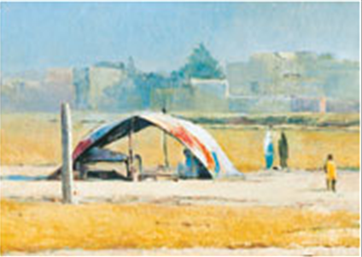
Figure 7. Khalid Iqbal, Gypsy Dwellings, Oil on canvas, 1980s.
The second is the mastery in capturing detail without compromising the character of a landscape. The extent of detail is quite important; it has to meet a certain degree in order to appear real. A greater detail would render a depiction super-realist and therefore artificial, a lesser detail would be like painting an impression. Khalid Iqbal is prodigious in recognizing the extent of detail. In the following painting, the blades of grass are neither clear nor blur, the surface of water is expressed through the right tone. The composition is selected to give an idea of a Village’s overall impact on the viewer. The sun casts light on the walls of the mud houses, their reflection in water creates the illusion required for harmonizing separate components into a unified whole. As the stream of water recedes, a gradual mist adds in. The composition is made from an angle that a viewer can feel that he or she is standing on the ground to observe the scene. The most remarkable feat of a realist is that a scene should appear as ordinary as it is, and Khalid Iqbal masterfully accomplishes this.
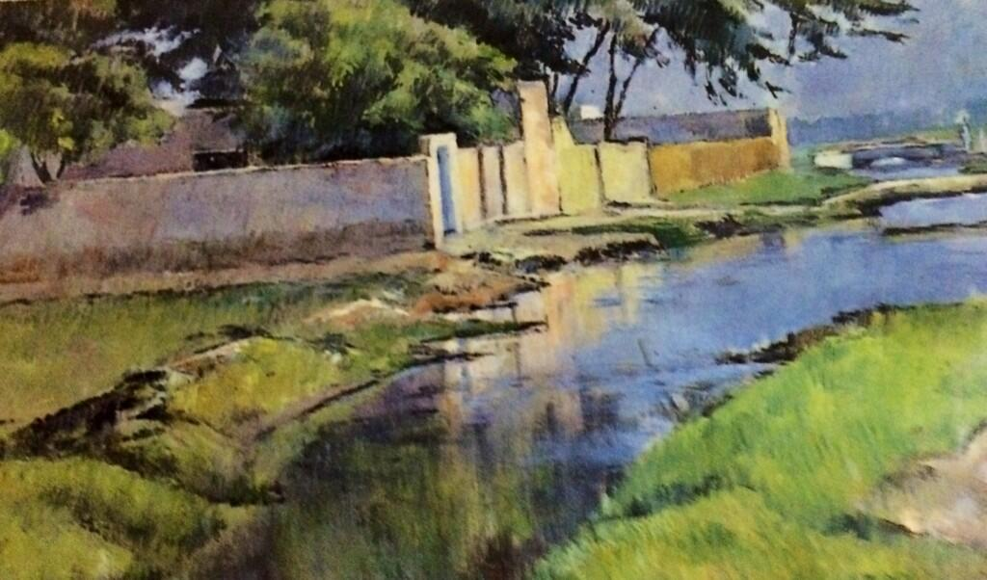
Figure 8. Khalid Iqbal, Samsani Village, Oil on canvas, 1980s.
The third usage is about depicting extraordinary tactile features of the atmosphere. A rather unusual rendition by Khalid Iqbal is the nocturnal atmosphere depicted in the following painting. The skeletal tree standing in the midst with a misty background with tents is all what one can observe. The most remarkable aspect is that the density of atmosphere is so tangible that one can actually feel the temperature; it’s a cold winter morning when mist engulfs the suburbs of Lahore. The tents are only slightly visible, which perhaps show their insignificance being the dwellings of the down-trodden. To achieve this accuracy, Khalid Iqbal used to paint on the spot daily around the same time. He ensured that he is able to observe the right tone of the light at the same time as it took several days to complete a painting.
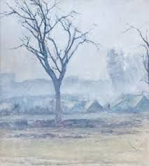
Figure 9. Khalid Iqbal, Misty Morning, Oil on canvas, 1990s.
Khalid Iqbal has shown the power of observation on the one hand and on the other the mastery of technique to translate observation onto canvas. His landscape paintings are most accurate depictions of the landscape of Punjab, its climate and the overall atmosphere, however, with a statement on the rural-urban divide; a powerful socio-economic feature defining cultural identity in Punjab.
Conclusion
Although Ustad Allah Bakhsh and Khalid Iqbal had difference of a generation, had entirely different learning curves, and fundamentally different approaches to landscape painting, both shared a common interest. Their paintings are statements or visual arguments on the cultural identity of Punjabi people. The cultural identity in Punjab particularly of the rural population is integrally connected to the land. The farmer earns his bread and butter from the land and therefore there is a profound love for Punjab. Both Ustad Allah Bakhsh and Khalid Iqbal were inhabitants of the Punjab region, had deeply connected identity with Punjabi culture. Ustad Allah Bakhsh found it in the colorful and symbolic epic stories depicting a rich past, Khalid Iqbal focused on the stark reality of present. Ustad Allah Bakhsh showed the romantic, Khalid Iqbal depicted the real but in both cases, the viewer is reminded of the land that has been the foundation of cultural identity. Whether it is Ranjha sitting at the Bank of Ravi in a colorful and vibrant setting, or a gypsy child standing aimlessly near his tent with parched grass in subdued colors, both belong to the same region and are nurtured by the same land, and both show us the range within cultural identity.
Bibliography
* College of Art & Design, University of the Punjab, Lahore
** College of Art & Design, University of the Punjab, Lahore
Alam, Nadeem. “The Ustad of Ustaads.” DAWN.COM, July 26, 2015. https://www.dawn.com/news/1195894.
Canaday, John. Neoclassic to Post-Impressionist. Norton, 1969.
Department, Michigan State University Political Science. Technology in the Western Political Tradition. Cornell University Press, 1993.
Donnachie, Ian L., Ian Donnachie, and Carmen Lavin. From Enlightenment to Romanticism: Anthology I. Manchester University Press, 2003.
Explorer, Pakistan. “Ustad Allah Bakhsh (1885-1978): One of the Greatest Oil Painters of Pakistan.” Pakistan Explorer (blog), September 4, 2012. https://www.pakistan-explorer.com/2012/09/04/ustad-allah-bakhsh-1885-1978-one-of-the-greatest-oil-painters-of-pakistan/.
Faflak, Joel, and Julia M. Wright. A Handbook of Romanticism Studies. John Wiley & Sons, 2012.
Goldman, Bernard. “Realist Iconography: Intent and Criticism.” Journal of Aesthetics and Art Criticism 18, no. 2 (1959): 183–192. https://doi.org/10.2307/427265.
Heinrich, Christoph. Monet. Taschen, 2000.
Husain, Marjorie, Nadeem Alam, Barbara Schmitz, and Rahat Naveed Masud. A Journey of Resilience and Success, 1940-2013: College of Art and Design, University of the Punjab, Lahore, 2013.
Judge, Paramjit S., and Gurpreet Bal. Reconstructing Identities: Society Through Literature. Rawat Publications, 2008.
Leslie, Charles Robert. Memoirs of the Life of John Constable, R.A. Medici Society, Limited, 1937.
Major, J. Russell. The Western World Renaissance to the Present, 1966.
Naqvi, Akbar. Image and Identity. 2 edition. Karachi: Oxford University Press, 2011.
Schneider, Joanne. The Age of Romanticism. Greenwood Publishing Group, 2007.
Soofi, Mushtaq. “PUNJAB NOTES: Village: Natural Beauty and Human Ugliness.” DAWN.COM, November 19, 2018. https://www.dawn.com/news/1446409.
Stokstad, Marilyn. Art History Combined. 3rd edition. Upper Saddle River, N.J: Pearson College Div, 2007.

Ian L. Donnachie, Ian Donnachie, and Carmen Lavin, From Enlightenment to Romanticism: Anthology I (Manchester University Press, 2003), xi.
John Canaday, Neoclassic to Post-Impressionist (Norton, 1969), 734.
Joanne Schneider, The Age of Romanticism (Greenwood Publishing Group, 2007), 46.
Joel Faflak and Julia M. Wright, A Handbook of Romanticism Studies (John Wiley & Sons, 2012), 60.
J. Russell Major, The Western World Renaissance to the Present, 1966, 504.
Charles Robert Leslie, Memoirs of the Life of John Constable, R.A. (Medici Society, Limited, 1937), liv.
Michigan State University Political Science Department, Technology in the Western Political Tradition (Cornell University Press, 1993), 124.
Marilyn Stokstad, Art History Combined, 3rd edition (Upper Saddle River, N.J: Pearson College Div, 2007), 1017.
Bernard Goldman, “Realist Iconography: Intent and Criticism,” Journal of Aesthetics and Art Criticism 18, no. 2 (1959): 187, https://doi.org/10.2307/427265.
Mushtaq Soofi, “PUNJAB NOTES: Village: Natural Beauty and Human Ugliness,” DAWN.COM, November 19, 2018, https://www.dawn.com/news/1446409.
Nadeem Alam, “The Ustad of Ustaads,” DAWN.COM, July 26, 2015, https://www.dawn.com/news/1195894.
Pakistan Explorer, “Ustad Allah Bakhsh (1885-1978): One of the Greatest Oil Painters of Pakistan,” Pakistan Explorer (blog), September 4, 2012, https://www.pakistan-explorer.com/2012/09/04/ustad-allah-bakhsh-1885-1978-one-of-the-greatest-oil-painters-of-pakistan/.
Paramjit S. Judge and Gurpreet Bal, Reconstructing Identities: Society Through Literature (Rawat Publications, 2008), 31.
Akbar Naqvi, Image and Identity, 2 edition (Karachi: Oxford University Press, 2011), 112.
Marjorie Husain et al., A Journey of Resilience and Success, 1940-2013: College of Art and Design, University of the Punjab, Lahore, 2013, 124.
Christoph Heinrich, Monet (Taschen, 2000), 32.
Naqvi, Image and Identity.

